ISLAM IN BIBLE PROPHECY
(The 7th Trumpet; 3rd Woe)
https://fccdl.in/tIivjP916d
Ref #: 28

- Jeremiah 4:19 Sound of trumpets = War

“UNDER THE FIRST FOUR TRUMPETS(of Revelation 8) THE TWO WESTERN DIVISIONS(of Rome) FELL, AND UNDER THE FIFTH AND SIXTH THE EASTERN EMPIRE WAS CRUSHED…” {1842 JoL, PREX2 133.1}

- Jeremiah 4:20 These trumpets cause major destruction

Review of 6th trumpet, 2nd woe:
- Trumpet #6 started on July 27, 1449 and ended on August 11, 1840
NOTE: The 1st Angel’s Message of Revelation 14:6 is connected to another angel, which is the original angel of the
3 Woes of Revelation 8:13
See Revelation 14:9,8,6; Revelation 8:13

NOTE: 2nd Woe ends on August 11, 1840, then Revelation 10:1-3 takes place (See 10MR 314.1)
This is the short time (1840-1844) between the end of the 2nd Woe and the beginning of the 3rd Woe

NOTE: Atheistic/Homosexual/Revolutionary France is mentioned between Revelation 11:1-13
This also takes place under the 2nd Woe, as it occurs between 1783 and 1798, which is 2nd Woe time period
We will be getting into this when we cover Daniel 11, part 3, on May 16, 2020
See “…the French revolution, is included in the second woe..." {May 31, 1843 JVHe, HST 103.27}

Revelation 11:14: “The second woe is past; and behold the third woe cometh quickly”

“Note the expression as to the coming of the third woe—it "cometh quickly." It did not come immediately upon the expiration of the sixth, as the sixth came immediately on the expiration of the fifth: there was a little space between the expiration of the sixth trumpet and the beginning of the seventh, which space is announced, and its shortness signified, by the word "quickly." And in this short space between the sixth and seventh trumpets, that mighty angel of Revelation 10 came in with his message, which was to sound over sea and land. {September 11, 1900 ATJ, ARSH 584.14} (This was between 1840-1844 after the Ottoman Empire Fell… See GC 335.1)

“IN 1844 THE THIRD WOE BEGAN…” {1864 UrS, KPC 44.2}

"And the seventh angel sounded, and there were great voices in Heaven saying, The kingdoms of this world are become the kingdoms of our Lord and of his Christ." Rev,xi.15. {1864 UrS, KPC 44.1}
THIS IS NOT THE LAST TRUMP WHICH WAKES THE DEAD [1 Cor.xv,52], AS SOME HAVE SUPPOSED. BUT IT IS LIKE THE TWO PRECEDING IT, A WOE TRUMPET. IT OCCUPIES DAYS [YEARS] IN SOUNDING. See Rev.x;7. "BUT IN THE DAYS OF THE VOICE OF THE SEVENTH ANGEL, WHEN HE SHALL BEGIN TO SOUND, THE MYSTERY OF GOD SHALL BE FINISHED, as he hath declared to his servants, the prophets." What is this mystery? The gospel to the Gentiles. Eph.i,9;iii,3;vi,19; Col.i,26;27;ii,2;iv,3. What is its finishing? A glance at the closing work of our great High Priest in the heavenly Sanctuary, is a sufficient answer. The commencement of this trumpet seems to be marked by the opening of the temple of God in Heaven [Rev.xi,19]; which took place at the end of the 2300 days, in 1844. See under Sanctuary. Solemn and fearful events are located under its sounding. IT INTRODUCES THE TIME, NOT WHEN THE WORLD WILL BE CONVERTED AND THE SPIRITUAL REIGN OF CHRIST BEGIN, BUT THE TIME WHEN THE DEAD SHALL BE JUDGED, all God's servants rewarded, and the destroyers [or corrupters] of the earth destroyed. UNDER THE SEVENTH TRUMPET THE SEVEN VIALS [Rev.xv,xvi] ARE POURED OUT. Read Rev.xi, from verse 15 to 19. Mark the events of verse 18: {1864 UrS, KPC 44.2}
***continue on next page***
“IN 1844 THE THIRD WOE BEGAN. IT EXTENDS INTO ETERNITY, COVERING ALL THE CORRUPTION OF THE LAST DAYS,-THE ANGER OR DISTRESS AMONG NATIONS, which was one sign of the second advent, as given by the Saviour. DURING THE SOUNDING OF THE SEVENTH TRUMPET, THE SEVEN LAST PLAGUES ARE POURED OUT; men, having rejected God, drink of the wine of His wrath. DURING THIS SOUNDING, THE RIGHTEOUS AND WICKED PASS THROUGH THE LAST GREAT TIME OF TROUBLE, in comparison with which the Reign of Terror in France(under the 2nd woe) was a. light affliction. DURING THIS WOE(the 3rd woe), THE SAINTS OF GOD WELCOME THE LORD IN THE CLOUDS OF HEAVEN, for He comes to give reward unto the faithful. THIS PERIOD CONTINUES OVER THE ONE THOUSAND YEARS FOLLOWING THE SECOND COMING OF CHRIST, AND ENDS WHEN SATAN AND ALL THE WICKED ARE REDUCED TO ASHES UPON THE SURFACE OF THE NEW EARTH, and all sorrow and sin are forever vanquished.” {1905 SNH, SSP 205.2}

“…THE SEVENTH TRUMPET, THE THIRD WOE, COVERS ALL THE WOE THAT WILL EVER BE ON THIS EARTH FROM THE TIME WHEN THIS TRUMPET BEGINS TO SOUND. But THE MYSTERY OF GOD IS TO BE FINISHED IN THE YEARS WHEN IT BEGINS—NOT AT THE LATTER PART, NOR AT THE END, BUT IN THE BEGINNING. WHENEVER, THEREFORE, THE SEVENTH ANGEL BEGINS TO SOUND, THE FINISHING OF THE MYSTERY OF GOD IS CLOSE AT HAND.” {September 18, 1900 ATJ)

“My very soul is filled with astonishment, when I see professed Advent believers, who HAVE BECOME SO BLIND AS NOT TO DISCOVER THAT THE THIRD WOE HAS COMMENCED(started), UNDER THE SOUNDING OF THE SEVENTH TRUMPET…” {July 10, 1845 SSSe, JUBST 138.3}

“Now IT IS QUITE APPARENT THAT THE SEVENTH ANGEL HAS BEGUN TO SOUND, AND THE THIRD WOE HAS COMMENCED ITS RAVAGES: WITNESS THE IMMENSE DESTRUCTION OF LIFE AND PROPERTY BY FIRE, WATER, ETC., ETC., DURING THE LAST FEW MONTHS(this was written in 1845). And now can we suppose that the prophetic periods extend beyond the sounding of the seventh angel?...” {June 19, 1845 SSSe, JUBST 114.2}

“FOUR MIGHTY ANGELS ARE STILL HOLDING THE FOUR WINDS OF THE EARTH. TERRIBLE DESTRUCTION IS FORBIDDEN TO COME IN FULL. THE ACCIDENTS BY LAND AND BY SEA; THE LOSS OF LIFE, STEADILY INCREASING, BY STORM, BY TEMPEST, BY RAILROAD DISASTER, BY CONFLAGRATION; THE TERRIBLE FLOODS, THE EARTHQUAKES, AND THE WINDS WILL BE THE STIRRING UP OF THE NATIONS TO ONE DEADLY COMBAT, WHILE THE ANGELS HOLD THE FOUR WINDS, FORBIDDING THE TERRIBLE POWER OF SATAN TO BE EXERCISED IN ITS FURY UNTIL THE SERVANTS OF GOD ARE SEALED IN THEIR FOREHEADS.” {ML 308.2} (See Matthew 24:3,7-8; Isaiah 13:8; GC 589-590)
See Also ‘The Coming King’ pages 277-278 by: James Edson White (Sister White’s son) (See 7MR 121.4)

***continue on next page***
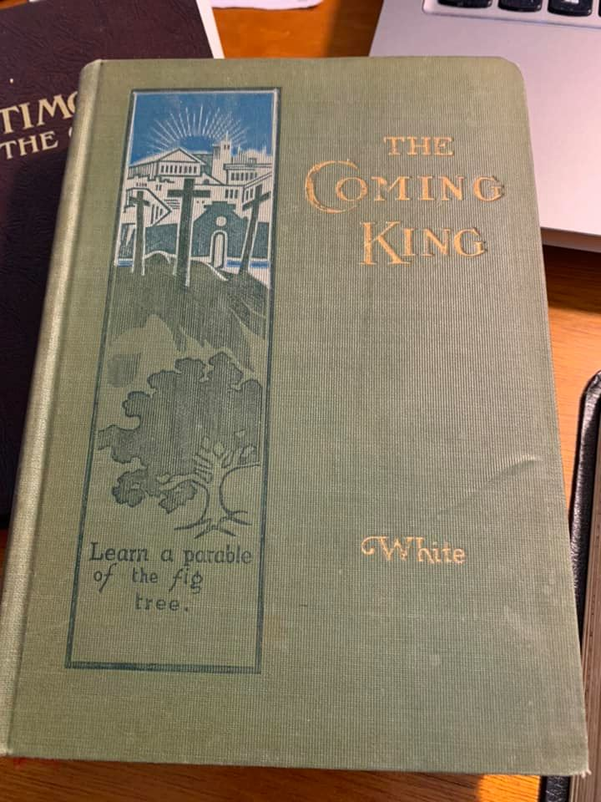
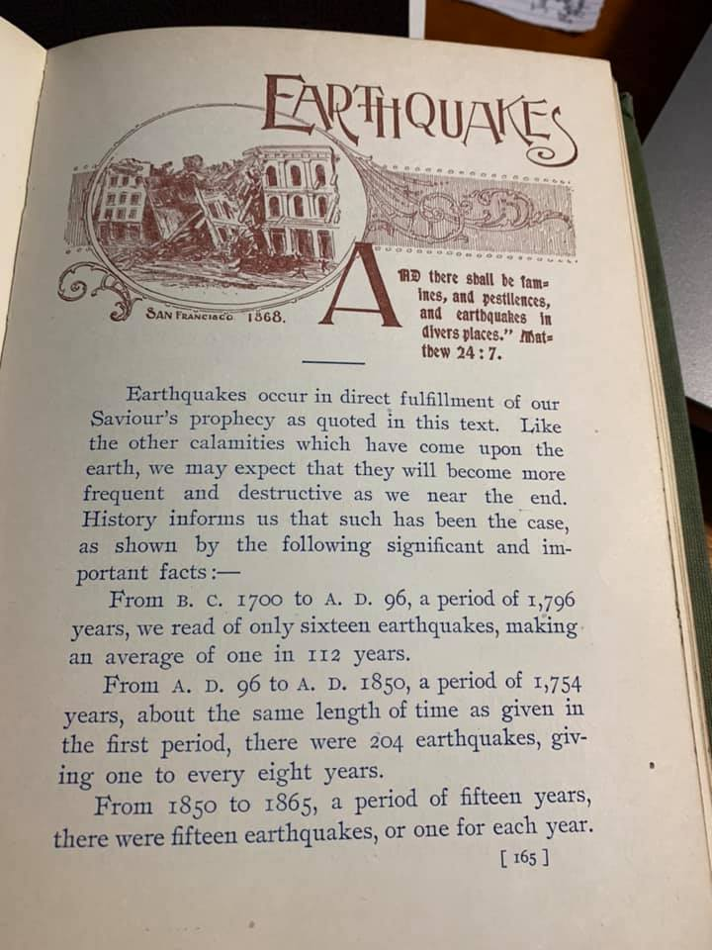
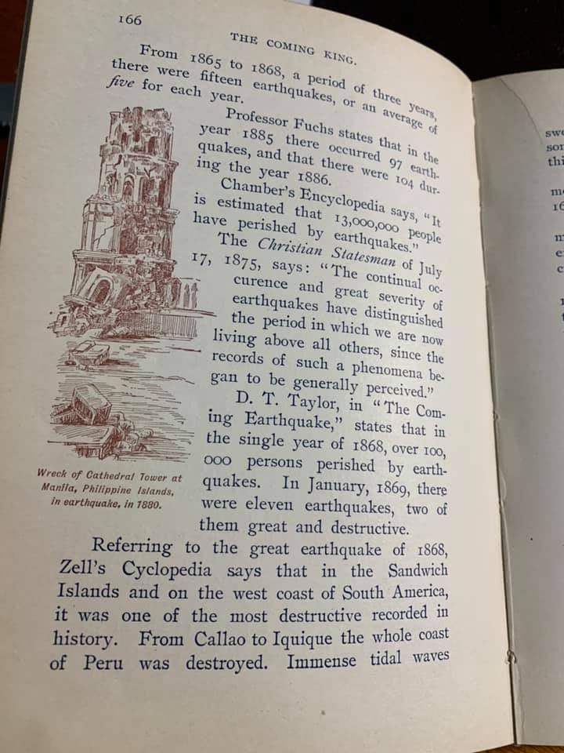
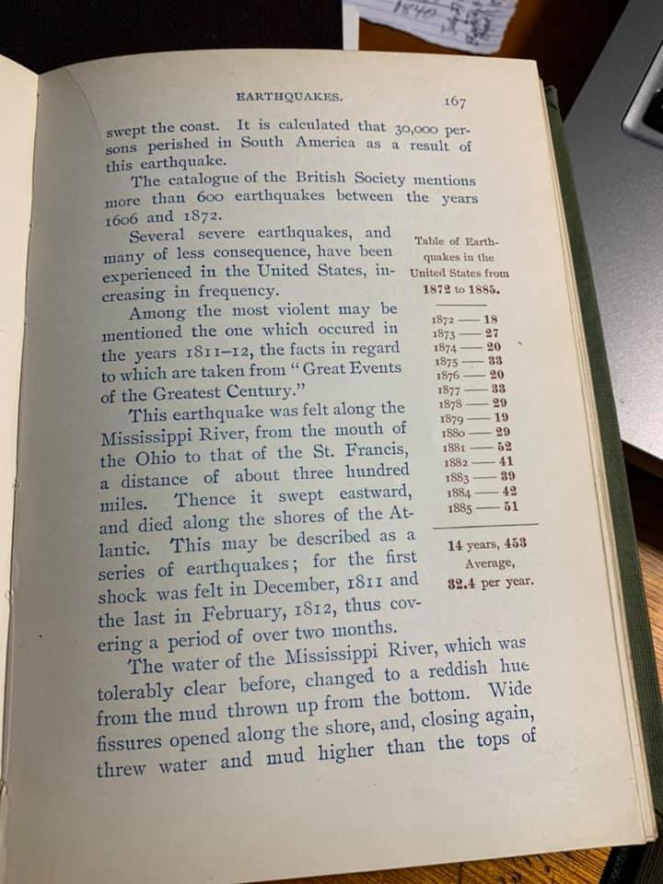
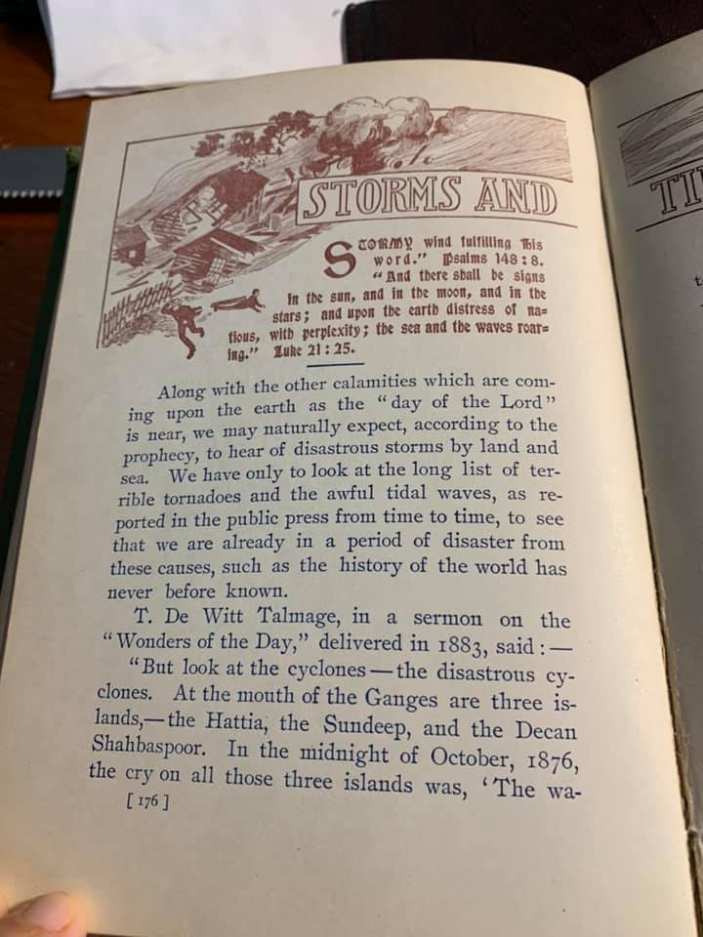
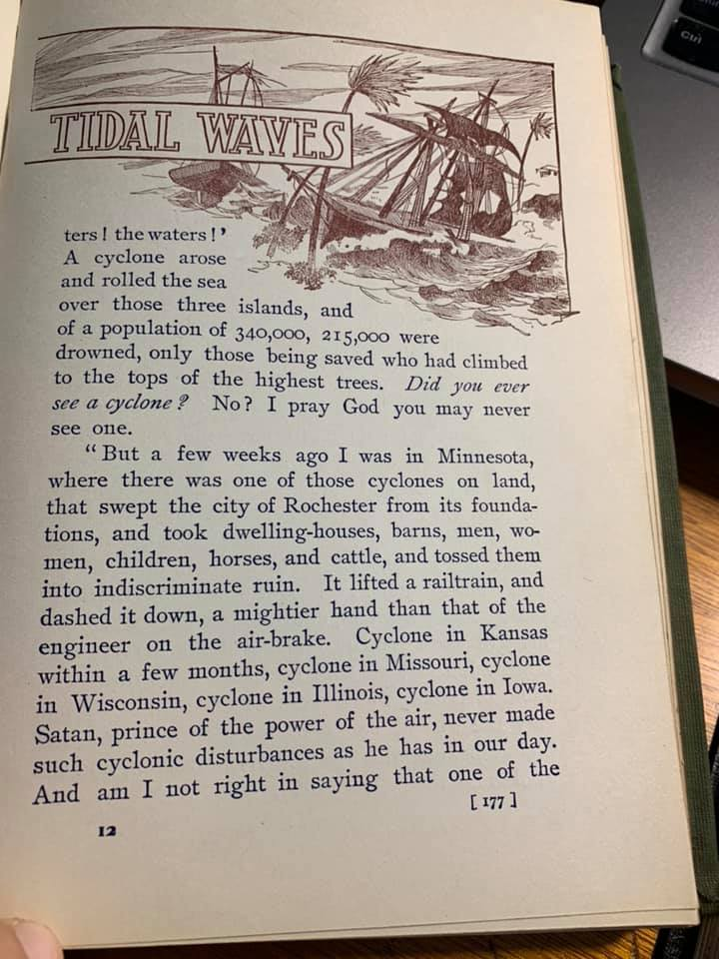
SUMMARY:

- The 7th Trumpet and 3rd Woe began at the same time
- They started on October 12, 1844 (get the date for this document)
- They include the starting of the earthquakes, floods, tornadoes, etc. and the increase
- Jesus going into the Most Holy Place and starting the judgment of the dead
- The Mystery of God/Godliness, meaning we can overcome sin, and have the character of Jesus in us.
- All the corruption of the last days
- The Enforcement of Sunday
- The 7 Last Plagues
- The Welcoming of the Savior (His 2nd Coming)
- The 1000 Years in Heaven
- The resurrection of the wicked
- When Satan and all the wicked are reduced to ashes upon the earth

THE 7 LAST PLAGUES ARE NOT SENT BY GOD, BUT BY HIS ENEMIES, WHICH IN LESSONS #33 AND #34 WE WILL LEARN THIS

“WE CANNOT KNOW HOW MUCH WE OWE TO CHRIST FOR THE PEACE AND PROTECTION WHICH WE ENJOY. IT IS THE RESTRAINING POWER OF GOD THAT PREVENTS MANKIND FROM PASSING FULLY UNDER THE CONTROL OF SATAN. THE DISOBEDIENT AND UNTHANKFUL HAVE GREAT REASON FOR GRATITUDE FOR GOD’S MERCY AND LONG-SUFFERING IN HOLDING IN CHECK THE CRUEL, MALIGNANT POWER OF THE EVIL ONE. BUT WHEN MEN PASS THE LIMITS OF DIVINE FORBEARANCE, THAT RESTRAINT IS REMOVED. GOD DOES NOT STAND TOWARD THE SINNER AS AN EXECUTIONER OF THE SENTENCE AGAINST TRANSGRESSION; BUT HE LEAVES THE REJECTORS OF HIS MERCY TO THEMSELVES, TO REAP THAT WHICH THEY HAVE SOWN…” {GC 36.1}

“I WAS SHOWN THAT THE JUDGMENTS OF GOD WOULD NOT COME DIRECTLY OUT FROM THE LORD UPON THEM, BUT IN THIS WAY: THEY PLACE THEMSELVES BEYOND HIS PROTECTION. HE WARNS, CORRECTS, REPROVES, AND POINTS OUT THE ONLY PATH OF SAFETY; THEN, IF THOSE WHO HAVE BEEN THE OBJECTS OF HIS SPECIAL CARE WILL FOLLOW THEIR OWN COURSE, INDEPENDENT OF THE SPIRIT OF GOD, AFTER REPEATED WARNINGS, IF THEY CHOOSE THEIR OWN WAY, THEN HE DOES NOT COMMISSION HIS ANGELS TO PREVENT SATAN’S DECIDED ATTACKS UPON THEM. { DE 242.1}

GOD WILL USE HIS ENEMIES AS INSTRUMENTS TO PUNISH THOSE WHO HAVE FOLLOWED THEIR OWN PERNICIOUS WAYS WHEREBY THE TRUTH OF GOD HAS BEEN MISREPRESENTED, MISJUDGED, AND DISHONORED.” {LDE 242.3}

THE ENEMIES THAT GOD HAS ALWAYS USED TO PUNISH HIS PEOPLE WHEN THEY BREAK HIS LAWS AND VIOLATE HIS SABBATH WERE THE PEOPLE OF THE NATIONS THAT ARE KNOWN AS MUSLIM NATIONS TODAY
- Leviticus 26:17,34,38,41
- Nehemiah 6:1
NOTE: God is the same yesterday, today, and forever (Hebrews 13:8)
NOTE: He used the Assyrian people to punish/scatter Israel and Judah (2 Kings 17:1-6; Jeremiah 50:17)
He used the Babylonian’s to punish/scatter Judah (Jeremiah 50:17)
These are both Muslim nations today
He used the Turks and Saracens to punish the Papal/Catholic Monks under the 1st Woe in the East
He used the Turks to punish the Papal/Catholics in the East by kicking them out of Constantinople
1st woe + 2nd woe = 3rd Woe
Islam will bring the Plagues (Revelation 18:4,8)
We will be learning more about this in lessons #33 and #34

***continue on next page***
QUOTES I MENTIONED EARLIER:
“NOW COMES THE WORD THAT I HAVE DECLARED THAT NEW YORK IS TO BE SWEPT AWAY BY A TIDAL WAVE. THIS I HAVE NEVER SAID. I HAVE SAID, AS I LOOKED AT THE GREAT BUILDINGS GOING UP THERE, STORY AFTER STORY: ‘WHAT TERRIBLE SCENES WILL TAKE PLACE WHEN THE LORD SHALL ARISE TO SHAKE TERRIBLY THE EARTH! THEN THE WORDS OF REVELATION 18:1-3 WILL BE FULFILLED.’ THE WHOLE OF THE EIGHTEENTH CHAPTER OF REVELATION IS A WARNING OF WHAT IS COMING ON THE EARTH. But I have no light in particular in regard to what is coming on New York, ONLY I KNOW THAT ONE DAY THE GREAT BUILDINGS THERE WILL BE THROWN DOWN BY THE TURNING AND OVERTURNING OF GOD’S POWER...” { LS 411.5}
NOTE: Jesus is saying through the prophet that the falling of the buildings of New York is a fulfillment of Revelation 18:1-3
NOTE: She calls these buildings “the great buildings of New York”, which were the twin towers (See 9T 12.1/13.1)
NOTE: Although the quote says this is God shaking terribly the earth, this is not the close of probation, as the quote continues on with the word “then” which means there is a continuation. And the “then” tells us Revelation 18:1-3 is fulfilled. We know this can’t be the close of probation, as the next verse in Revelation 18:4 is the cry for us to give to tell the people to come out of Babylon AND whatever other churches that are a cage of every unclean and hateful bird

“THE WHOLE EARTH IS TO BE LIGHTENED WITH THE GLORY OF THE LORD(this is Revelation 18:1 language). THE PURE IN HEART SHALL SEE GOD. IT IS THOSE WHO ARE FOLLOWING THE LAMB WHITHERSOEVER HE GOETH THAT WILL RECEIVE POWER FROM THAT ANGEL THAT CAME DOWN FROM HEAVEN “HAVING GREAT POWER.” THE FIRST MESSAGE IS TO BE REPEATED PROCLAIMING THE SECOND ADVENT OF CHRIST TO OUR WORLD. THE SECOND ANGEL’S MESSAGE IS TO BE REPEATED, “BABYLON THE GREAT IS FALLEN, IS FALLEN, AND IS BECOME THE HABITATION OF DEVILS, AND THE HOLD OF EVERY FOUL SPIRIT, AND A CAGE OF EVERY UNCLEAN AND HATEFUL BIRD. FOR ALL NATIONS HAVE DRUNK OF THE WINE OF THE WRATH OF HER FORNICATION, AND THE KINGS OF THE EARTH HAVE COMMITTED FORNICATION WITH HER, AND THE MERCHANTS OF THE EARTH ARE WAXED RICH THROUGH THE ABUNDANCE OF HER DELICACIES” [Revelation 18:2, 3]. {16MR 40.2}
NOTE: According to Jesus through the prophet, When Revelation 18:1 is fulfilled, the 1st Angel’s Message is to be repeated, followed by the 2nd Angel’s Message being repeated
NOTE: According to the prophet in the previous quote, Revelation 18:1-3 happens when the “great buildings” of New York fall
NOTE: So after 9/11, these 2 messages, starting with the 1st, were to be repeated?
WHY? Because the sign had come for them to be repeated

Q: Why is Babylon(the apostate churches of the U.S.) mentioned as having fallen 2 x?
A: THE SECOND ANGEL’S MESSAGE OF REVELATION 14 WAS FIRST PREACHED IN THE SUMMER OF 1844, AND IT THEN HAD A MORE DIRECT APPLICATION TO THE CHURCHES OF THE UNITED STATES, WHERE THE WARNING OF THE JUDGMENT HAD BEEN MOST WIDELY PROCLAIMED AND MOST GENERALLY REJECTED, AND WHERE THE DECLENSION IN THE CHURCHES HAD BEEN MOST RAPID. BUT THE MESSAGE OF THE SECOND ANGEL DID NOT REACH ITS COMPLETE FULFILLMENT IN 1844. THE CHURCHES THEN EXPERIENCED A MORAL FALL, IN CONSEQUENCE OF THEIR REFUSAL OF THE LIGHT OF THE ADVENT MESSAGE; BUT THAT FALL WAS NOT COMPLETE. AS THEY HAVE CONTINUED TO REJECT THE SPECIAL TRUTHS FOR THIS TIME THEY HAVE FALLEN LOWER AND LOWER. NOT YET, HOWEVER, CAN IT BE SAID THAT “BABYLON IS FALLEN(remember she wrote this in 1888, but now in 2020, it can be said that the apostate churches in the U.S. have completely fallen),... BECAUSE SHE MADE ALL NATIONS DRINK OF THE WINE OF THE WRATH OF HER FORNICATION.” SHE HAS NOT YET MADE ALL NATIONS DO THIS(not in 1888 she hasn’t, but since the falling of the great buildings of New York, she has). THE SPIRIT OF WORLD CONFORMING AND INDIFFERENCE TO THE TESTING TRUTHS FOR OUR TIME EXISTS AND HAS BEEN GAINING GROUND IN CHURCHES OF THE PROTESTANT FAITH IN ALL THE COUNTRIES OF CHRISTENDOM; AND THESE CHURCHES ARE INCLUDED IN THE SOLEMN AND TERRIBLE DENUNCIATION OF THE SECOND ANGEL. BUT THE WORK OF APOSTASY HAS NOT YET REACHED ITS CULMINATION. { GC 389.2}
NOTE: Remember once again. The above was written in 1888 and was put in the 1911 book as well. Since those dates, the U.S. churches have fallen, because the great buildings of New York was the sign that the message of the 2nd Angel was to be repeated, followed by the repeat of the 1st Angel’s, which means these churches have completely fallen
***continue on next page***
“ALL THE MESSAGES GIVEN FROM 1840-1844 ARE TO BE MADE FORCIBLE NOW, FOR THERE ARE MANY PEOPLE WHO HAVE LOST THEIR BEARINGS. THE MESSAGES ARE TO GO TO ALL THE CHURCHES.” {21MR 437.1}

WHY?
“THE SIGNS OF THE END ARE FAST FULFILLING. THE TIME OF TROUBLE IS VERY NEAR US NOW…” (21MR 437.5)

WHAT SIGN?
“ON ONE OCCASION, WHEN IN NEW YORK CITY, I WAS IN THE NIGHT SEASON CALLED UPON TO BEHOLD BUILDINGS RISING STORY AFTER STORY TOWARD HEAVEN. THESE BUILDINGS WERE WARRANTED TO BE FIREPROOF, AND THEY WERE ERECTED TO GLORIFY THEIR OWNERS AND BUILDERS. HIGHER AND STILL HIGHER THESE BUILDINGS ROSE, AND IN THEM THE MOST COSTLY MATERIAL WAS USED... {9T 12.1}

THE SCENE THAT NEXT PASSED BEFORE ME WAS AN ALARM OF FIRE. MEN LOOKED AT THE LOFTY AND SUPPOSEDLY FIRE-PROOF BUILDINGS AND SAID: “THEY ARE PERFECTLY SAFE.” BUT THESE BUILDINGS WERE CONSUMED AS IF MADE OF PITCH. THE FIRE ENGINES COULD DO NOTHING TO STAY THE DESTRUCTION. THE FIREMEN WERE UNABLE TO OPERATE THE ENGINES. {9T 13.1}

BUT WHO READS THE WARNINGS GIVEN BY THE FAST-FULFILLING SIGNS OF THE TIMES?...”{9T 14.1}

NOW GETTING TO THE PLAGUES:
- “THESE PLAGUES ARE NOT UNIVERSAL, or the inhabitants of the earth would be wholly cut off…” (GC 628.2)

- Islam brings the 1st 5 plagues to Babylon, specifically found in Europe and the U.S. (Revelation 16:1-11)

“THE WORLD IS STIRRED WITH THE SPIRIT OF WAR. THE PROPHECY OF THE ELEVENTH CHAPTER OF DANIEL HAS NEARLY REACHED ITS COMPLETE FULFILLMENT. SOON THE SCENES OF TROUBLE SPOKEN OF IN THE PROPHECIES WILL TAKE PLACE.” {9T 14.2}

“…THE ANGELS WILL BE BIDDEN TO LET GO, THAT THE FOUR WINDS MAY BLOW UPON THE EARTH. THAT WILL BE A DECISIVE TIME FOR GOD’S CHILDREN, A TIME OF TROUBLE SUCH AS NEVER WAS….” { 5T 152.2}

“…ANGELS ARE HOLDING THE FOUR WINDS, REPRESENTED AS AN ANGRY HORSE SEEKING TO BREAK LOOSE AND RUSH OVER THE FACE OF THE WHOLE EARTH, BEARING DESTRUCTION AND DEATH IN ITS PATH.” { 20MR 216.6 }
NOTE: The horse = Islam (Revelation 9:7,9,16,17)
NOTE: An angry horse(Islam) = Angry Islam

“FOUR MIGHTY ANGELS HOLD BACK THE POWERS OF THIS EARTH TILL THE SERVANTS OF GOD ARE SEALED IN THEIR FOREHEADS. THE NATIONS OF THE WORLD ARE EAGER FOR CONFLICT, BUT THEY ARE HELD IN CHECK BY THE ANGELS. WHEN THIS RESTRAINING POWER IS REMOVED THERE WILL COME A TIME OF TROUBLE AND ANGUISH. DEADLY INSTRUMENTS OF WARFARE WILL BE INVENTED. VESSELS WITH THEIR LIVING CARGO WILL BE ENTOMBED IN THE GREAT DEEP. ALL WHO HAVE NOT THE SPIRIT OF TRUTH WILL UNITE UNDER THE LEADERSHIP OF SATANIC AGENCIES, BUT THEY ARE TO BE KEPT UNDER CONTROL TILL THE TIME SHALL COME FOR THE GREAT BATTLE OF ARMAGEDDON.” (LDE 238.3} 1900
THE WHOLE WORLD WILL BE INVOLVED IN RUIN
ANGELS ARE NOW RESTRAINING THE WINDS OF STRIFE THAT THEY MAY NOT BLOW UNTIL THE WORLD SHALL BE WARNED OF ITS COMING DOOM, BUT A STORM IS GATHERING, READY TO BURST UPON THE EARTH, AND WHEN GOD SHALL BID HIS ANGELS LOOSE THE WINDS THERE WILL BE SUCH A SCENE OF STRIFE AS NO PEN CAN PICTURE.” (LDE 239.1} 1903

***continue on next page***
- The Papacy and the U.S. gather the world together to bring the 6th Plague to Islam in their territory by the Euphrates River (Revelation 16:12-16)

NOTE: We will go more into depth on the 7 last plagues when we do our topic ‘The 7 Last Plagues’ parts 1 and 2

